**Assignment 11.6**

**Problem Statement:**

Find the top five kinds of GoogleKnowlege_Occupation people who were guests in the show, in a particular time period i.e., between '1/11/99' and 6/11/99. You need to write an UDF to compare the dates.

**Input:**

<https://github.com/prateekATacadgild/DatasetsForCognizant/blob/master/dialy_show_guests>

**Program:**

* **UDF**

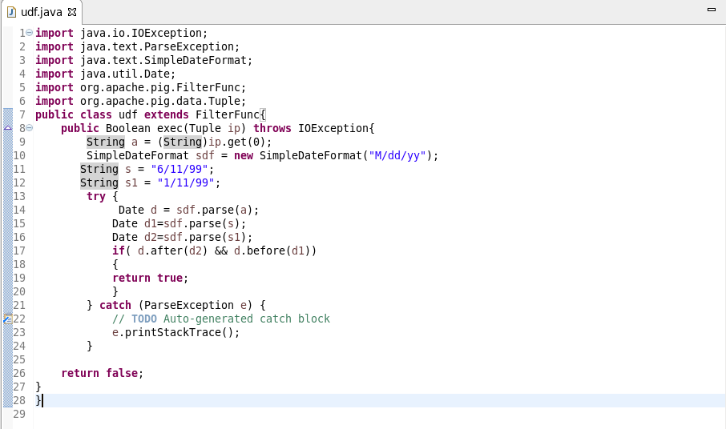

* **Pig script**

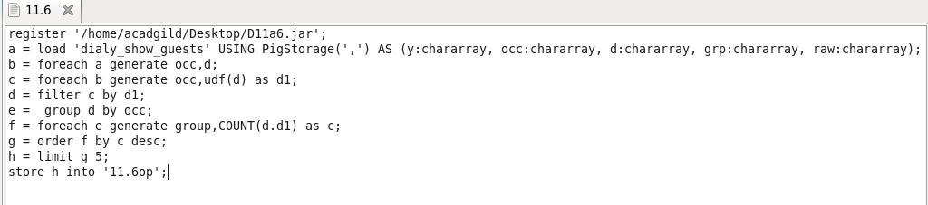

**Output:**

